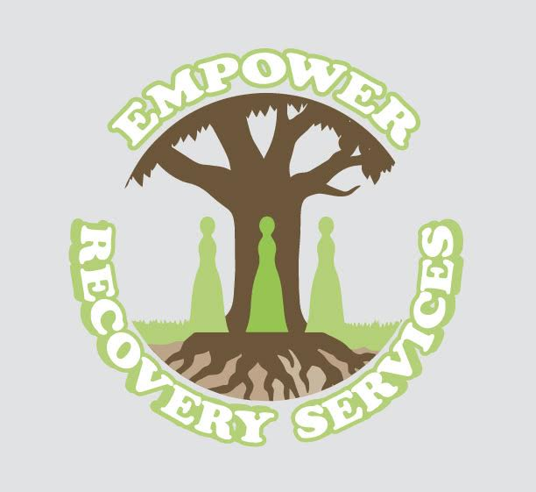

**Women's Sober Living Intake Application**

**Personal Information** Full Name: _______________________________________________

Date of Birth: ___________________________________________

Phone Number: _________________________________________

Email Address: __________________________________________

Current Address: _____________________________________________________________

Emergency Contact Name: ___________________________________________

Relationship: ___________________________________________

Emergency Contact Phone Number: ______________________________________________

**Medical History** Do you have any current medical conditions? [ ] Yes [ ] No  
If yes, please describe: ___________________________________________

Are you currently taking any prescribed medications? [ ] Yes [ ] No  
If yes, list medications and dosages: ____________________________________________________________________________________________________________________________________________________________________________________________________

Do you have any allergies? [ ] Yes [ ] No  
If yes, please describe: ___________________________________________

**Medical Insurance Information** Insurance Provider: ___________________________________________

Policy ID and Group Number: _____________________________________________________________

Primary Care Physician: ___________________________________________

Physician Contact Number: ________________________________________

**Probation/Parole Information** Are you currently on probation or parole? [ ] Yes [ ] No  
If yes, please provide details: ___________________________________________

Probation/Parole Officer Name: ___________________________________________

Contact Number: ___________________________________________

**Substance Use History** What substances have you used in the past?___________________________________________ _________________________________________ Date of last use: ___________________________________________

Have you undergone detox for substance use? [ ] Yes [ ] No  
If yes, please provide details: ___________________________________________

**Treatment History** Have you previously participated in a treatment program? [ ] Yes [ ] No  
If yes, please provide details: ___________________________________________

Have you previously lived in a sober living home? [ ] Yes [ ] No  
If yes, please provide details: ___________________________________________

**Goals and Motivation** What are your goals for sobriety and personal growth? __________________________________

_________________________________________________________________________________________________ What support do you feel you need from the sober living community? ________________________________________

_________________________________________________________________________________________________

**House Rules Acknowledgment** I understand that living in a sober house requires me to follow all house rules, maintain abstinence from substances, and participate in recovery programs.

Signature: ___________________________________________

Date: ___________________________________________

**For Office Use Only** Intake Interview Conducted By: ___________________________________________

Date: ___________________________________________

Accepted into Program: [ ] Yes [ ] No  
Move-in Date: ___________________________________________